**Model Development Phase Template**

|  |  |
| --- | --- |
| Date | 10 July 2024 |
| Team ID | 739659 |
| Project Title | Trip-Based Modelling of Fuel Consumption in Modern Fleet Vehicles Using Machine Learning |
| Maximum Marks | 4 Marks |

**Initial Model Training Code, Model Validation and Evaluation Report**

The initial model training code will be showcased in the future through a screenshot. The model validation and evaluation report will include classification reports, accuracy, and confusion matrices for multiple models, presented through respective screenshots.

**Initial Model Training Code:**

Paste the screenshot of the model training code

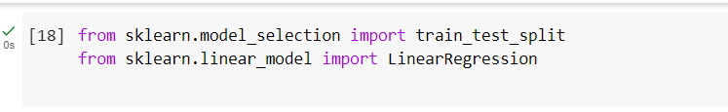

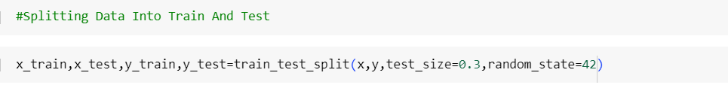

Linear regression

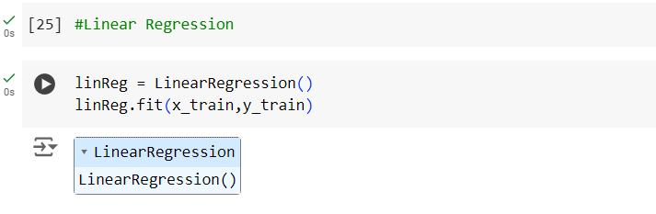

Lasso Regression

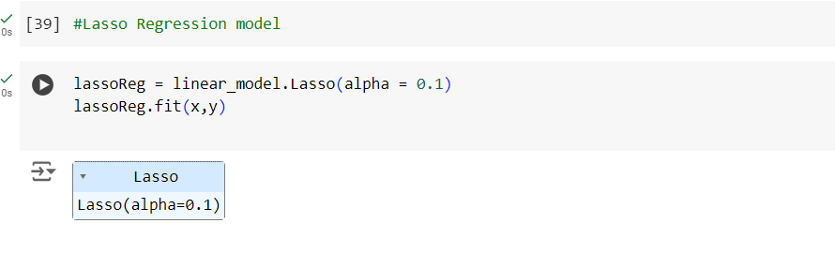

Decision Tree

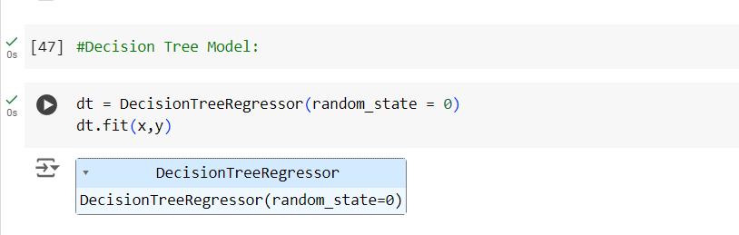

Random Forest

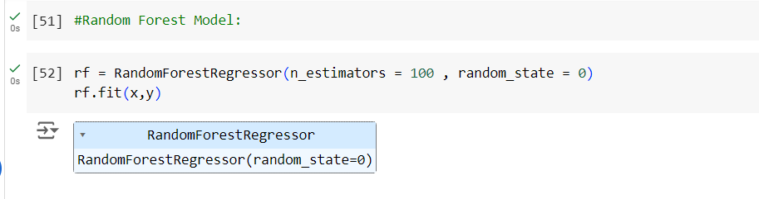

**Model Validation and Evaluation Report:**

|  |  |  |  |
| --- | --- | --- | --- |
| **Model** | **Training Report** | **Accuracy** | **Metrix** |
| Linear Regression |  | 0.11 |  |
| Lasso  Regression |  | 0.14 |  |
| SVM |  | 0.41 |  |
| Decision  Tree |  | 0.98 |  |
| Random forest |  | 0.93 |  |